With the development of electronic industry, the scale of transistors on the chip is becoming smaller and smaller and the number is becoming larger and larger. Consequently, the heat dissipation becomes a critical issue. At small length scales, the classical diffusion-based model for heat conduction begins to fail. This makes the prediction of heat transfer in Micro-and-nano scale difficult. In dielectric materials (semiconductors and insulators), heat is mainly carried by lattice vibration, which is called phonon, while in metal the main contributor is electron. In our group, we study the thermal conductivity of semiconductors, insulators, metals, and polymers using multiscale methods, including first-principles method, molecular dynamics and Boltzmann transport equation. We also do some thermal engineering application researches, such as electronic heat dissipation, laser manufacture, phase change heat storage material, and solar energy harvest.

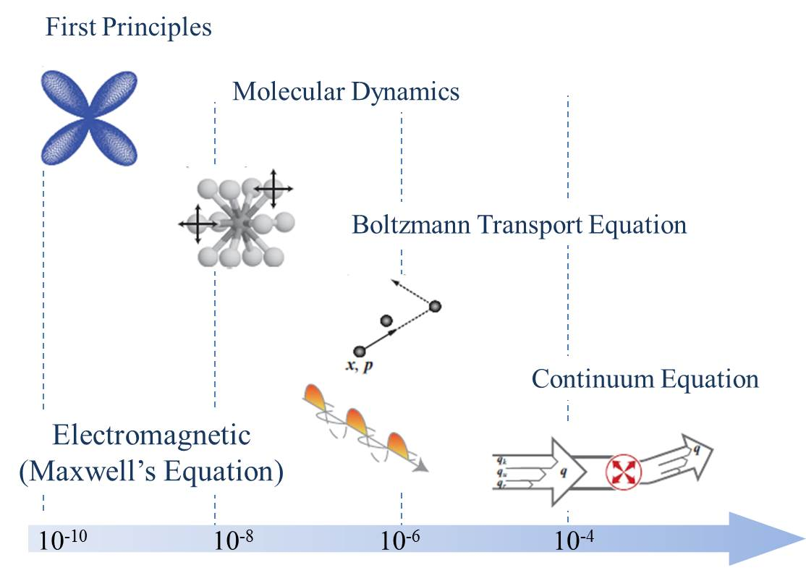

**Molecular dynamics simulation**

MD simulations involve calculating the trajectories of particles within a system by numerically integrating classical equations of motion. From this trajectory, the system properties can be extracted as MD simulations supply detailed descriptions of the heat transfer mechanisms within nanostructures because surface, interface and impurity effects are all naturally included. In a preliminary study of a Lennard Jones crystal we analyzed the systems normal modes to learn how the modes propagate and the rate at which they decay. This information can then be used to calculate the frequency dependent contributions to the thermal conductivity, as the method can also be applied to other materials of interest.

**First-principles method**

Heat in semiconductor materials is conducted by lattice vibrations and a proper description of these requires an accurate knowledge of second order and third derivatives of energy with respect to atomic displacements also known as the interatomic force constants. In the first-principles based approach these force constants are derived from density-functional perturbation theory and used along with a solution of the Boltzmann transport equation in the single-mode relaxation time approximation to predict thermal conductivity. This approach offers the advantage of being free of any adjustable parameters and has a general applicability. We have used this approach to predict thermal conductivity in materials. By now, this is the most accurate method to predict thermal conductivity.

**Boltzmann transport equation**

When a temperature gradient exists over length scales comparable to phonon mean free paths (MFPs), local thermal equilibrium does not exist and Fourier’s law is no longer valid. Length scales are much larger than phonon wavelength so we do not need to care about wave effect. In this regime, particle-based approaches based on Boltzmann transport equation may be used. This approach can use the parameters provided by First-principles calculation to describe mesoscale heat conduction. In past research, we have used different methods to solve the complex Boltzmann transport equation and built procedures based-on these methods. And now, we will use these procedures to study mesoscale heat conduction phenomenon.

**Heat conduction in multiscale porous media**

The porous media has complicated microstructures and the important thermal transport property, effective thermal conductivity, is a common interest in studying the heat conduction in porous media. To investigate the heat transfer in porous media, several numerical methods can be applied. In macroscopic scale, the heat transfer is governed by heat diffusion and can be modeled by Effective medium approximation method, finite difference methods and so on. In mesoscopic scale, the Lattice Boltzmann method can be used to perform the simulation of heat transfer. In particular, the nanoscale heat transfer in low dimensional materials, such as graphene, quite differs from other materials. Molecular Dynamics simulation, wave packet simulation and some other numerical methods can be used to study the heat transfer and perform the thermal conductivity calculation in nanoporous materials. Using these simulation methods, we can investigate the heat transfer mechanisms in these nanomaterials.